# SYD366 Assignment – Group Component

John Richard Bozar | Rickson Bozar | Diego Felipe | Luca Novello

Dec 1, 2024

## Class Diagram:

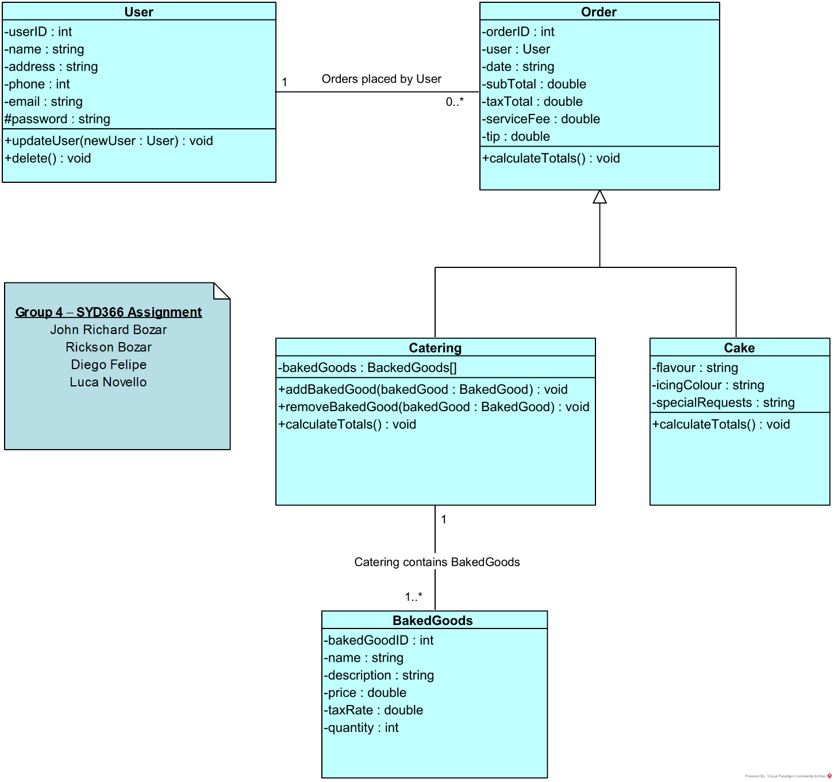

## Controller Classes:

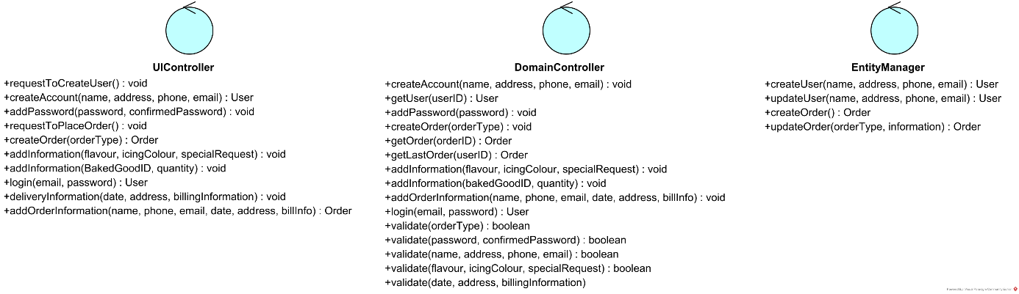

## Sequence Diagram – Create User:

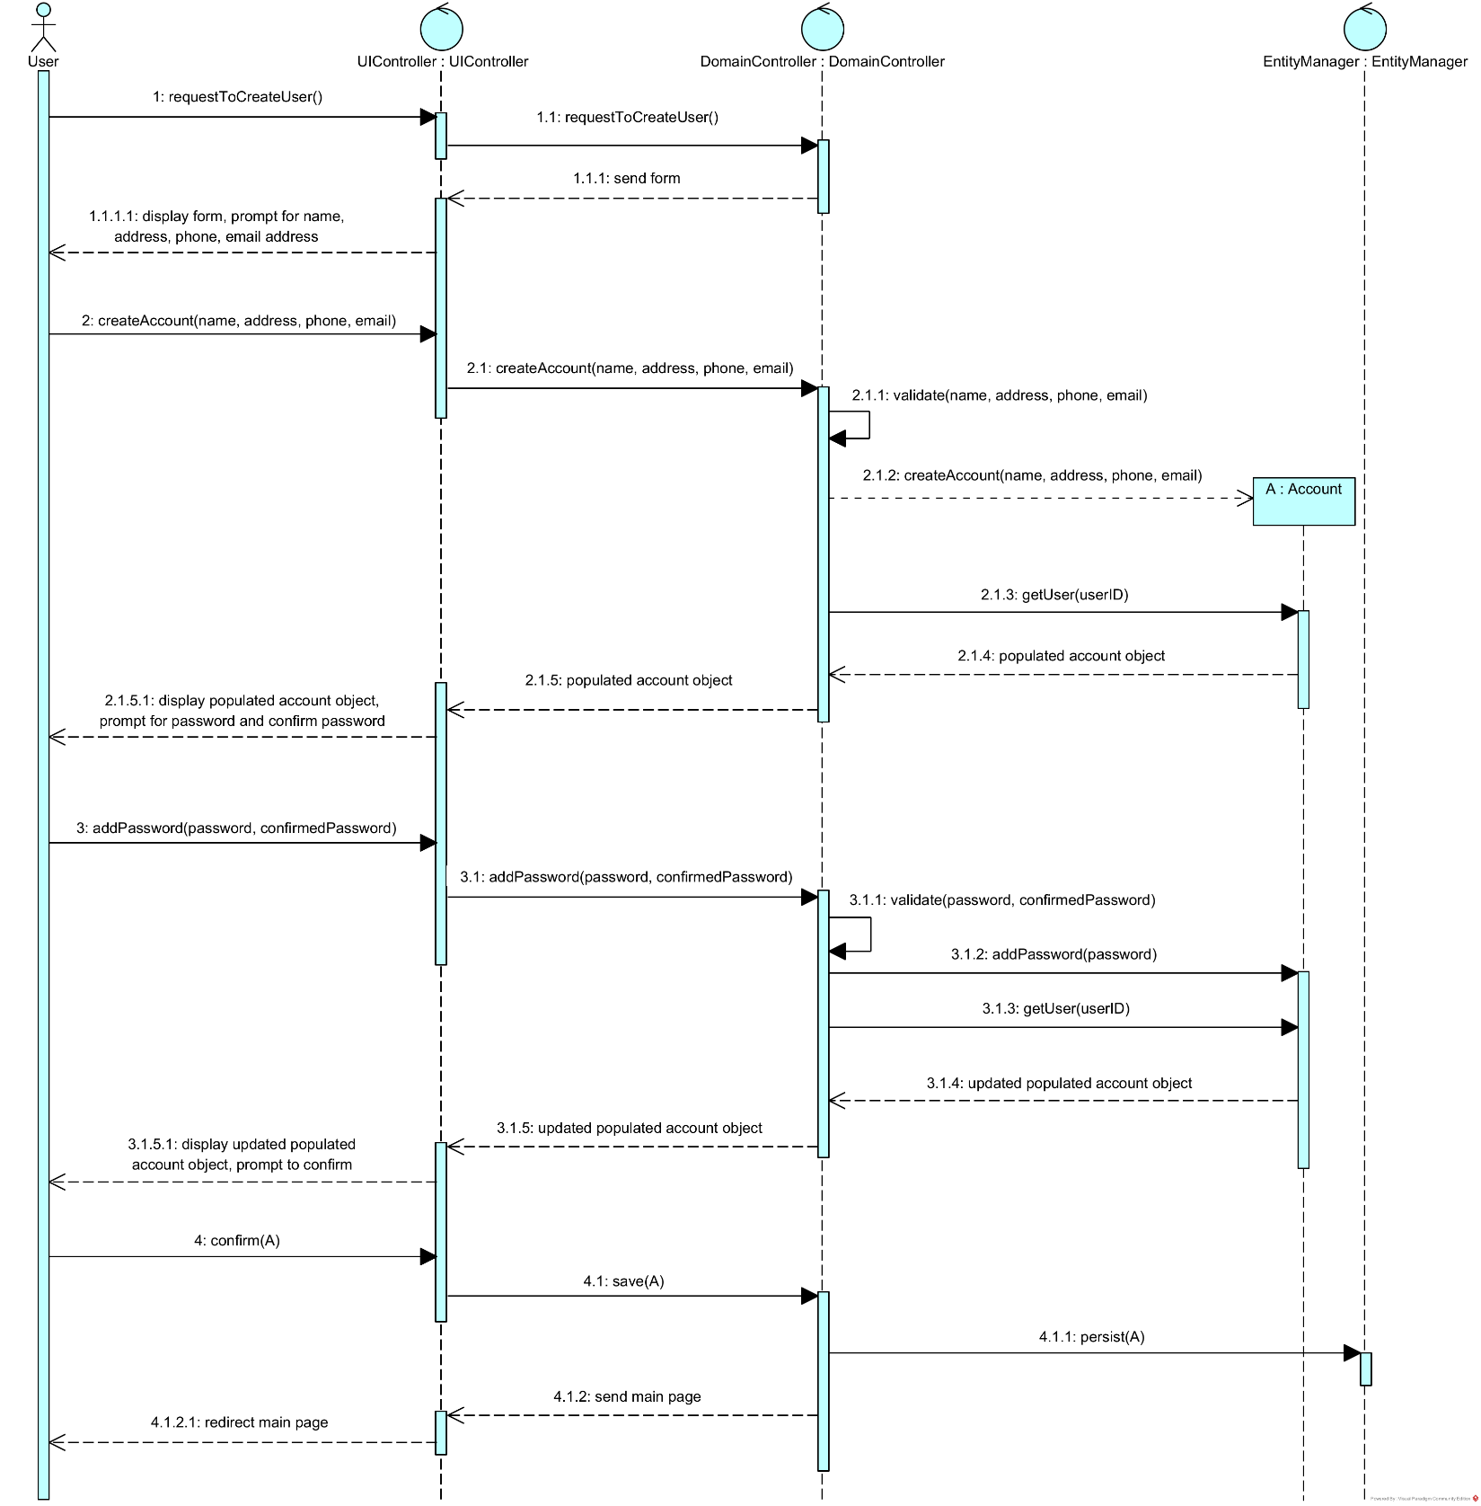

Sequence Diagram – Place Order:

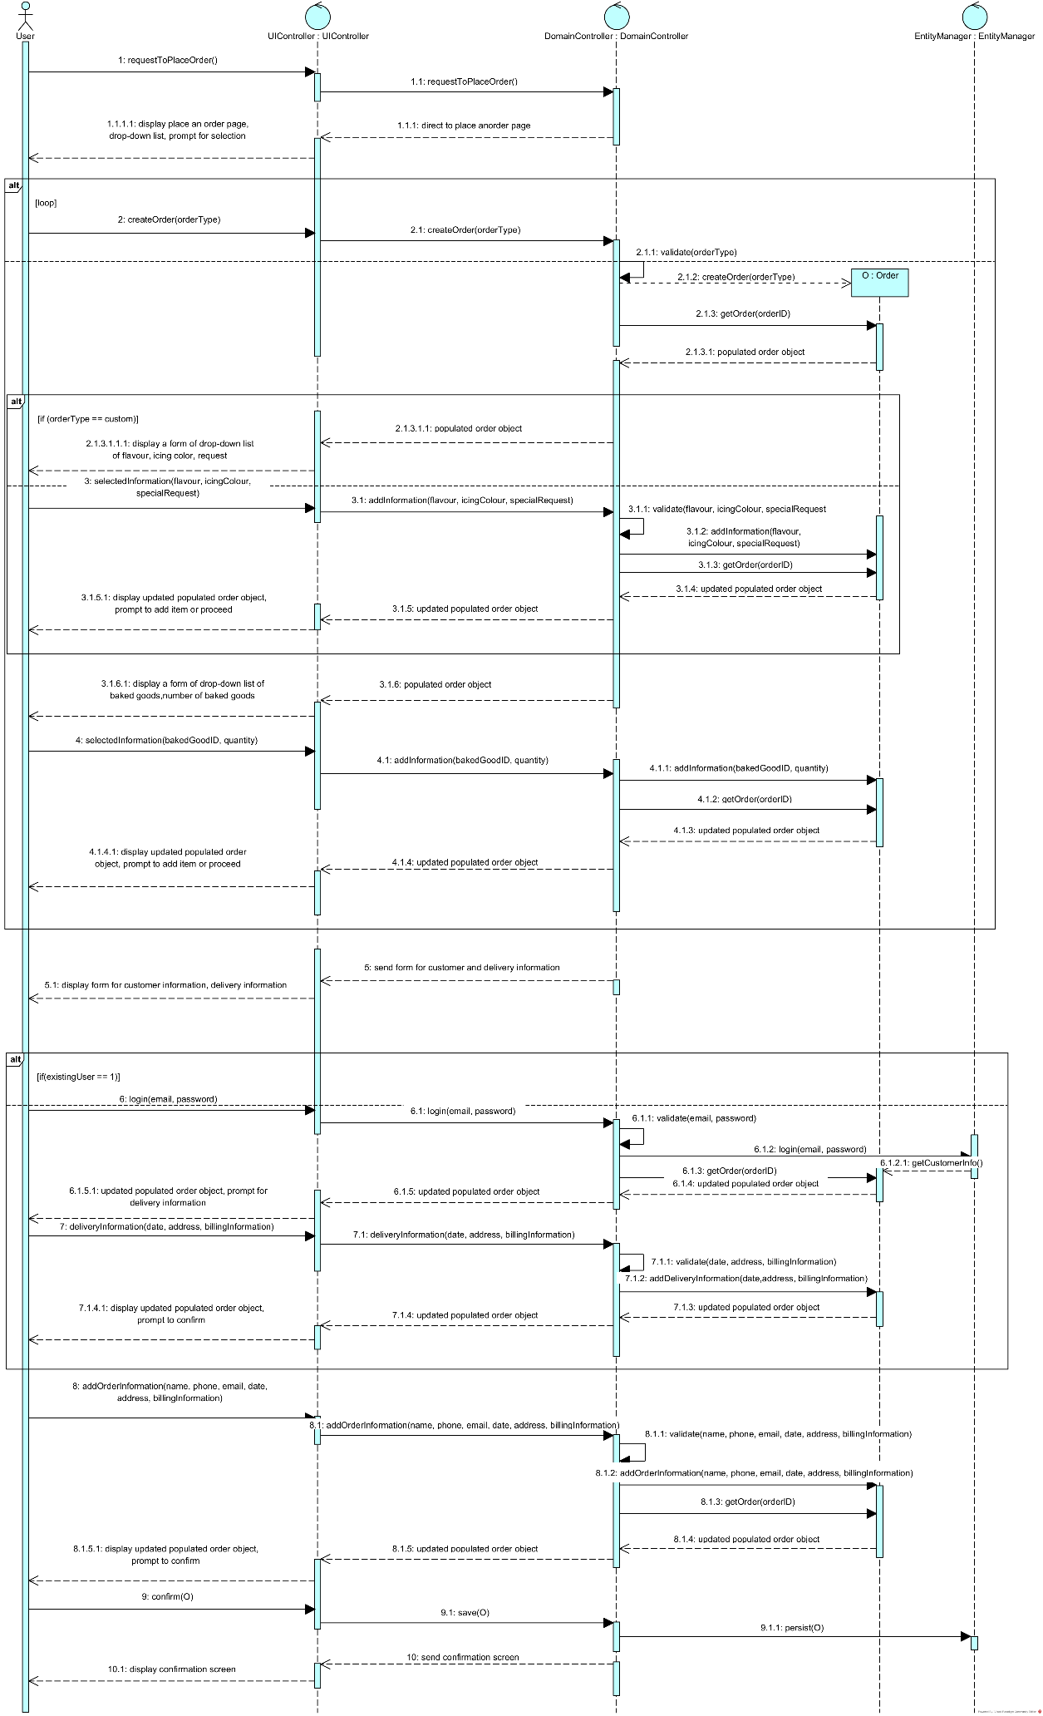

## Wireframe – Create User:

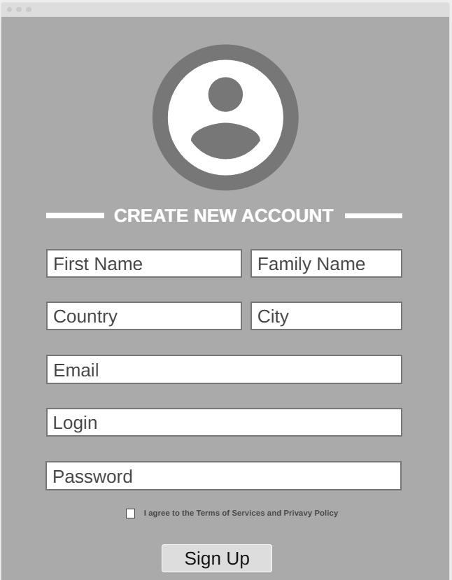

**Menu:** Account Information and navigation.

**Order Main Section:**

* Repeat Previous Order button
* Form to enter details such as:
  + Name
  + Address
  + Email address
  + Phone number
  + Login in information
  + Password
  + Sign Up button

## Wireframe – Place Order:

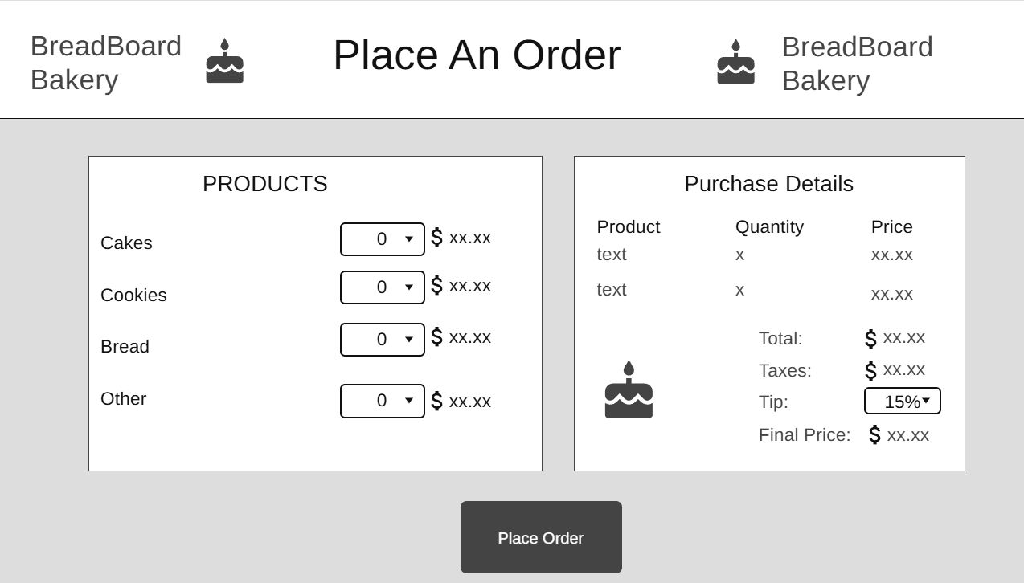

**Menu:** Account Information.

**Order Main Section:**

* Repeat Previous Order button
* Form to enter details such as:
  + List of Baked Goods and options
  + List of Baked Goods added to Order
  + Totals
  + Confirmation button

## Additional Functionality:

* John Richard Bozar: Gift Card Feature
  + The gift card feature allows customers to purchase gift cards for friends and family, making it a perfect gift option for any occasion. It’s designed to be simple and user-friendly, encouraging more sales and spreading brand awareness. This feature not only benefits customers but also increases customer retention and loyalty for the bakery.
* Rickson Bozar: Reward Point System Feature
  + This feature lets customers earn points from their purchases, which helps both the customer and the owner. It makes customers more likely to return, and it helps the owner see which customers buy regularly.
* Diego Felipe: Discount System Feature
  + Introduce a discount system that allows customers to receive discounts based on specific conditions or promotions. This feature will enhance customer satisfaction and encourage repeat purchases.
* Luca Novello: Repeat Last Order
  + Allows the customer to place a new order with the same items from their last order. This can be useful for customers that make repeat orders and could help users streamline the customer order process.